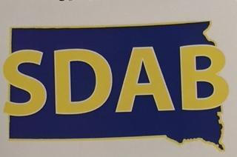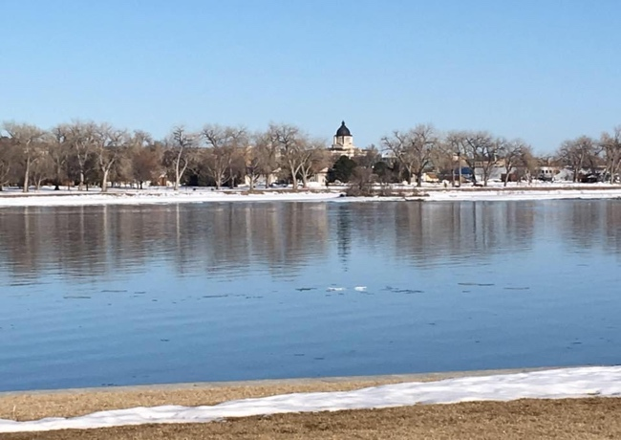
As Eye See It
Special Edition
January 2021 Volume 28 Issue 8
Koni is pictured enjoying a warm day in her three-season room.
Taking a Look Back and Preparing for the Future
Like many of you the new year causes me to reflect back and look forward. Our past year has been very challenging in a lot of ways. We held off on our last newsletter due to Covid. It was a difficult decision. As we tried to plan it became clear we just didn’t have the articles to present. Covid had affected our newsletter more than we thought. We also needed to look forward to events such as Disability Day at the Capitol. How can SDAB provide something to the legislatures that would be interesting and show what we do? I want to thank Seth Sims for coming up with our “Special Edition” idea. What a wonderful way to showcase some of our previous favorite articles and some new information. We have tried to update articles with new details where available and let you know which newsletter they were originally published in.
As we go through the year, remember this is your newsletter. We are always looking for your ideas, stories and participation. You do not need to be on the board or a committee to send things our way. We have some very active members out there. We would be excited to let everyone know how special you are!
Until our next newsletter, remember being kind can make the world of difference in someone’s day. Here are a few ideas: smile, read a book to someone, say hello to a stranger, bake a treat for a neighbor, write a letter to a nursing home resident or soldier, give a compliment to as many people you can, or pay it forward. I know you can think of many more!
Everyone has their own personal issues and trials they are going through. Let us all remember to be kind and caring to each other. I hope we can continue to transparency and open communication. Each and every one of you are IMPORTANT to SDAB! Our nation is so divided right now. It is sad to see so many citizens forget we are one nation. We can have our opinions, but we need to respect each other. As our state motto reads “Under God the People Rule”. We elect our legislators, and they take pride in representing us the people. Thank you to the legislators for all your work.

In This Newsletter
Page
Greetings from the President 2
SDAB Board and Officers 4 ExpressVote: The New Voting Machine Replacing AutoMark 5-6 Transportation Panel 7 ACB - What Is It and Why We Should Care 8 Happy Birthday Louis Braille!!! 9 Walk By The Way Homeschool Class 10 Sioux Falls Area Metro Meetings 11 American Council of the Blind’s DC Leadership Meetings 12-15 Learning in the Apple Tree 16 Need Help! 17 The Traveling Bear 18 History of the South Dakota State Seal 19-20
Blind Blunders 20 Courtesies to Extend to a Person with a Guide Dog 21 As Eye Cook It 22 Looking Ahead to 2021 SDAB Convention 23

U.S. Department of Transportation Announces Final Rule 24-25 on Traveling by Air with Service Animals Membership Form 26-27

Mailing Label 28

____________________________________________________________

Our Mission Statement
The mission is to support and advocate for the full inclusion of persons who are blind and visually impaired into all aspects of society. This is accomplished through public education, peer support, community service, self and systems advocacy, and developing and supporting legislation.

2021 South Dakota Association of the Blind Board and Officers
Mailing Address: PO Box 1622 Sioux Falls, SD 57101-1622
Facebook: South Dakota Association of the Blind
Website: http://www.sd-sdab.com
Officers:
President: Koni Sims: Sioux Falls - sdabpresident@gmail.com, 605-941-9512
1st V-President: Virginia Miller: Dell Rapids - ginnyandterry@siouxvalley.net, 605-428-3651
2nd V-President: Eric Rippentrop: Aberdeen – eric.m.rippentrop@gmail.com, 605-261-3117
Secretary: Lerae Olesen: Sioux Falls - lerae@rapidnet.com, 605-978-9267
Treasurer: Alan Vandenburg: Sioux Falls – r2linepass@yahoo.com, 605-351-9355

Board of Directors:
Tevan Fischbach: Aberdeen – tevan.fischbach@sdsbvi.northern.edu, 605-226-2574
Doug Puetz: Rapid City – 605-593-7531
Nick Pavel: Sioux Falls – nick.pavel9@gmail.com
605-661-7707
Jackie Shepherd: De Smit, jackiesheperd49@gmail.com,
503-853-4141
Seth Sims: Sioux Falls – sksims87@gmail.com, 605-339-9512
Erwin Wiest: Eureka – erv1972@valleytel.net, 605-282-9093

ExpressVote: The New Voting Machine Replacing AutoMark
I would like to share with you some information about the new voting machine that is replacing the AutoMark. It’s called the ExpressVote. Seth and I had the opportunity to use it April 4th when we did absentee voting. I also had the chance to visit with Tom Greco, the City Clerk. He was excited to share the information about the machine and wanted our thoughts and feedback. This is some of things I shared with him and his responses. He also shared a document/picture of the machine. Please let me know if you have any thoughts or concerns. He has asked that I share any information I receive with him and Bob Litz, the County Auditor. I noticed there was no writing on our ballots, I thought that was interesting. How does the machine know what to read?
The ballot is different from the traditional 8 1/2 x 14 (or longer) ballots in that it's 4 1/2 inches wide. The ballot is referred to by the manufacturer as an "activation card." There is a barcode on each ballot that activates the voter's vote session on the screen. Once choices are made, the ballot is printed only with the voter’s selections. This ballot is readable by the machines we use on election night to tally votes cast. For tabulation, each selection is associated with a barcode identifier as well.
In November when it’s a bigger ballot, will it work the same? The ExpressVote ballot may potentially be longer in length, but the concept is the same. The card activates the ballot choices on-screen, the voter selects, and the machine prints the selections.
Seth thought it was hard to hear. I know I had to turn it way up, think there was a lot of noise that made it hard. This is unfortunate and I'll be sure to look at the headphones we are using for that particular machine. I hope it's just the headphones and not the system. In either case, we'll keep an eye on it.
It was nice to be able to hold the controls. That was great. An observation I made is that we need to ensure workers detach the keypad from the body of the machine, so users know it's there.
Is this a statewide machine? To my knowledge, not all jurisdictions have replaced their AutoMARKS with the ExpressVote, but many have. I know both Minnehaha and Lincoln have made the transition. The system and associated software are certified by the Secretary of State. One final note, the system does not store voter data. Like the AutoMARK it only prints (in this case) choices (AutoMARK marked a regular ballot).
Tom also shared, after discussing this with some seasoned precinct workers there is one additional thing you may want to pass on. In the past with AutoMARK voters were able to simply request a ballot and often did not "ask" to use the AutoMARK. But since the ExpressVote uses a different type of ballot, it may be best to let the precinct worker know an ExpressVote ballot is desired. If this step is skipped, the voter can always return the traditional ballot and receive an ExpressVote one. Thanks again for your help and advice.
Koni Sims

This article was originally presented in our April 2019 Newsletter. All precincts now have the ExpressVote.

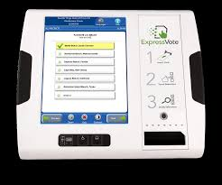
Pictured is an ExpressVote machine.

Transportation Panel
The discussion panel on transportation was moderated by Shelly Pfaff. The panel included Sam Trebilcock, the transportation planner for Sioux Falls, Brenda Schweitzer, the executive director of the Brookings Area Transit Authority, and Doug Puetz, a consumer of the bus system in Rapid City. The discussion mainly involved the bus systems in South Dakota and the challenges the blind community faces in securing dependable transportation, both around their cities, as well as traveling throughout the state. In Sioux Falls alone, the city has overgrown its existing bus lines, leaving a large portion of the city without access to bus routes. Unfortunately, one of the biggest challenges that the transit system is currently facing is a severe lack of funding. Bus fares do not even cover 10% of the cost of providing bus services. As our communities continue to grow and the need for public transportation increases, it is unclear what the future will hold for the public transit systems in South Dakota. As consumers, the blind community would benefit from getting involved on transit boards and making their voices heard. Anyone who has questions regarding the transit system can call the 211 Helpline for support.
This article is from the November 2018 issue. The panel met at our SDAB Convention in Sioux Falls during September 2018.

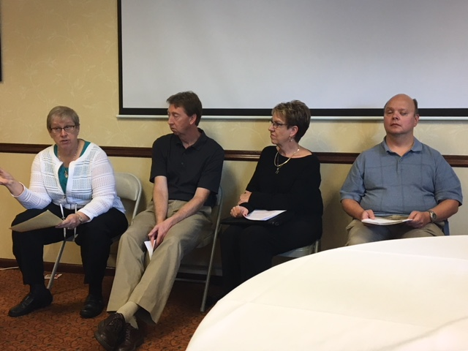
Pictured is Shelly Pfaff, Sam Trebilcock, Brenda Schweitzer, and Doug Puetz.

ACB - What Is It and Why We Should Care
When you fill out a membership form to join SDAB, you can indicate what format you would like to receive both this newsletter and the ACB Braille Forum (American Council of the Blind). SDAB is just one of 70 state and special-interest affiliates of the ACB. Organized in 1961, the founders believed in a grass-roots organization where each affiliate could govern itself while still belonging to the ACB. That’s why $5.00 of your annual membership dues is sent to the ACB every year. Also, at the annual convention, the number of votes allocated to each affiliate is based on the number of members whose names we have submitted. It’s a little like the House of Representatives in Congress, in that the more members we have, the more votes we have on the convention floor. Members are free to voice their opinions and make choices. In SDAB our bylaws give term limits to the president, first vice president, and second vice president, so that one person doesn’t maintain power for decades. Since the beginning, ACB has worked on a number of national issues which affect us today. If you receive funds from the Social Security Administration, you have the right to receive your correspondence from them in multiple formats. Such as read over the phone, braille, large print or CD. If you go to a movie, you can ask the for an audio description device with a headset. This will enable you to follow the action on the screen without your friend telling you what’s happening. ACB is still working with the Department of Treasury to incorporate currency that is readily accessible. ACB does not claim to be the voice of all blind people. In addition to reading the Forum, you can listen to ACB radio online at www.acbradio.org. There are several “stations” including news of interest to the blind, ACB Radio Interactive, featuring blind DJ’s playing several genres of music, or you can listen to the conventions of several state affiliates. During the Summer, if you aren’t able to attend the national conference and convention, you can listen live. You might just hear a familiar SDAB member’s voice during the roll call at opening session. Several of our own SDAB members have attended national conventions throughout the years and they can tell you more about what it’s like to be at convention and, well, why you should care. To listen to the ACB Braille Forum or ACB Reports over the phone, call (605) 475-8154. To listen to ACB Radio over the phone, call (712) 775-4808. For more information you can visit: www.acb.org.
Lerae Olesen
This was featured in the December 2019 newsletter.
Happy Birthday Louis Braille!!!

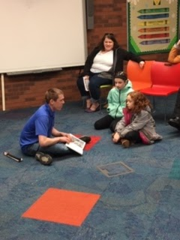
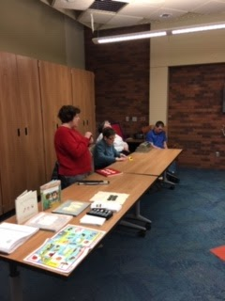
January 4th is Louis Braille’s birthday. Today we use braille as a form of communication. South Dakota Association of the Blind thanks Mr. Braille for his communication invention for the blind and remembers his birthday in celebration. During the week of his birthday, SDAB, along with the Siouxland Library, held a seminar on braille for children and adults. A podium in the library had braille books, a braille writer, and other information on Louis Braille. A huge thank you to Koni Sims and Chelle Hart for the organization of this event! On Saturday, January 26th we held a braille demonstration at the library. Roughly about 8 children and their parents learned all about braille. Children’s names were typed in braille for him or her, information was read, and a story was read to the children in braille by Nick Pavel. The children really seemed to enjoy themselves asking good questions, and they had smiles all around! We hope to continue this event and bring more awareness to the braille system. Some local mass media organizations helped with making this event aware to the public. Koni Sims and Chelle Hart were interviewed on local television stations. Koni was also interviewed on the radio. We hope to continue this event in the years to come in celebration of braille. Those in attendance and helping included Koni Sims, Chelle Hart, Lerae Olesen, Deb VerSteeg, Nick Pavel, and Eric Rippentrop. Top picture is Chelle Hart speaking to the group. Bottom picture is Nick reading to children.

This was originally shown in the April 2019 issue.

Walk By The Way Homeschool Class
The Siouxland Chapter had the opportunity to work with 28 students and some parents about blindness skills. The event was held Friday, March 29th at Hillcrest Church in Sioux Falls. Members that participated were Virginia Miller, Nick Pavel, Lerae Olesen, Chelle Hart, Eric Rippentrop, Seth Sims, and Koni Sims. We divided the kids into 5 groups. The 5 area of skills that were taught include: guide dog/white cane/sighted guide training. Reading a twin book which means the book is braille, print, and pictures. The history of braille, demonstrating how it is written and letting them write their names in braille. They learned about different eye conditions and low vision aids that are available. Resource that are available. The last area was technology. They heard how the PC computer talks. iPhone accessibility options, the state library player for listening to books. The kids had the had chance to try the equipment. Other technology was also talked about. At the end we had them draw a letter then they had to come figure out what cookie had the letter on it. The letters were in braille on the cookies using red hots. The comments we heard were “very interesting”, “we learned a lot”. We have really enjoyed doing these demonstrations for homeschool kids. We want to thank Holly Carnes, WBTW co-op coordinator, for reaching out to us.
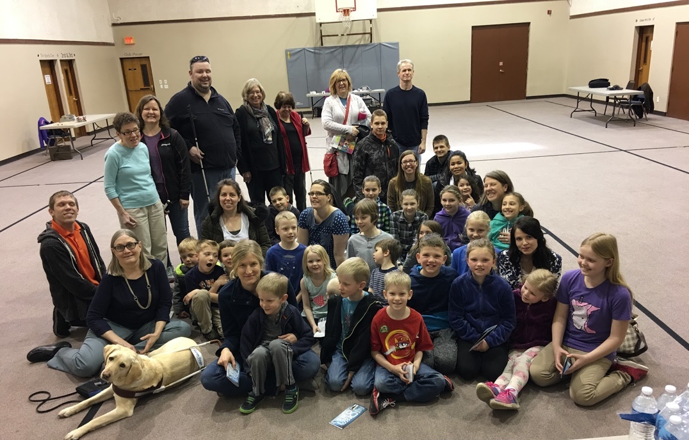
Pictured left to right is Virginia Miller, Wiggles (guide dog), Nick Pavel, Lerae Olesen, Holly Carnes,
Eric Rippentrop, June Tietz, Chelle Hart, Seth Sims, along with parents and school children.

We look back to the April 2019 issue for this article.
Sioux Falls Area Metro Meetings
Sioux Area Metro, or SAM, is the local bus service in Sioux Falls, South Dakota. Once a month all employees have to attend a safety meeting that is mandatory. The April meetings were held on the 22nd to the 25th. The Siouxland chapter was asked to come speak about experiences with the SAM service. All employees of SAM would be present at one time or another. From the top official in the office to the janitors cleaning the station would lend his or her pair of ears to this presentation. Through speaking to one another, personal experiences, and different topics heard in passing a list was constructed of items to speak of. Granted, not all issues would be able to be covered in one hour, but some major concerns were covered.
Seth Sims, Koni Sims, and Eric Rippentrop attended these meetings held at the local SAM Administration Building in Sioux Falls. I believe we came to the office with topics that needed to be addressed. Easy reminders to call street crossings on the bus speaker system and give the right of way to pedestrians. Letting a blind or visually impaired person aware of distance from curb or ice on the sidewalk in the winter were a few topics covered to name a few. We also took some time and explained different eye conditions and how different conditions affect the sight. The big enforcer was when we handed out visual simulation cards so the employees can have a slight glimpse into the world of a person who is blind or visually impaired. All the presentations were given a simulation cards and all employees took one home with him or her and participated in this activity.
All in all, the presentation was a huge success. To this day I am still receiving comments about how helpful that presentation was and how drivers think all new employees should go through this training. They stated it was nice to hear it from our prospective. Management stated this is the first time they have never had any questions for the presenters. Even SAM is excited about bringing this important issue up at future meetings. A huge thank you to Sioux Area Metro for giving some time to a crucial topic in our community.
Eric Rippentrop
Since this appeared in our August 2019 issue a pilot program started in December 2020. This created an opportunity for On Demand service on Saturdays only. This replaces the fixed routes and will run for a trial period of four months. Currently the website and mobile app are not accessible for the blind and visually impaired to request this service.
American Council of the Blind’s DC Leadership Meetings
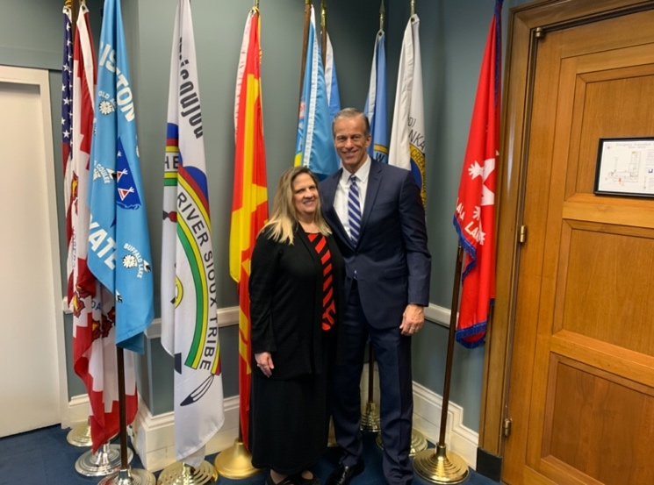
On February 22nd through the 25th, I had the opportunity to attend my first ever ACB leadership/legislative meetings. Seth was planning on going with me but had to cancel right before our trip due to illness. ACB radio broadcast all the meetings live so he was able to listen at least.
On Saturday the ACB board meeting was held. It wasn’t mandatory but felt it was a good opportunity to see how the board works. During the day I started to meet national staff that I have worked with via email and phone. By the time the meeting got over I was networking with other leaders on concerns and issues.
Sunday was called the Affiliate Presidents’ Meetings. Other leaders also attended. We started the day hearing from Development/Fundraising Steering Committee. The Board of Publications presented next with the key 2020 initiatives. Scholarship and Awards talked about the opportunities available to members for the conference/convention in July. By late morning we had breakout sessions. They divided the room into 2 groups. The back half had to go to another room. I was sitting in the front half with the North Dakota group, so we got to stay. The panelist switched when it was time to switch so everything was always live on the radio. The first breakout session dealt with Audio Description projects. There are a lot of great projects going on. We learned that through Verizon if you have 5G you can get Disney Plus free for a year. The second breakout session was concerning Information, Referral, and Peer Support. This session was informative. We discussed what ACB has available and what each affiliate has so we can support and share information. The lunch speaker, Joe Strechay, was a blind actor/co-producer of the TV series “See” on Apple TV Plus. Janet Dickelman shared convention updates. The afternoon started with breakout sessions. Membership Services, Embrace, Engage, Empower started us off. Cindy Van Winkle shared what ACB has been doing to show our members they matter. She has a team called the POSSE that has been reaching out to members and to affiliate presidents. She is starting a Humpday Happy Hour for affiliate presidents to call in and visit. Get to know each other and share any concerns or problems. Public Awareness – connecting with ACB was presented by Kelly Gasque. She shared all the different ways to connect with our members and general public. The resources available through ACB. VisionServe Alliance talked about collaboration with ACB. Lee Nasehi is President and CEO of VisionServe Alliance. He has written a book for nonprofits called “Traction” and also has some podcasts. Tony Stephens discussed how important Zoom is for affiliate virtual meetings. Joel Snyder shared what is happening in the world of audio description.
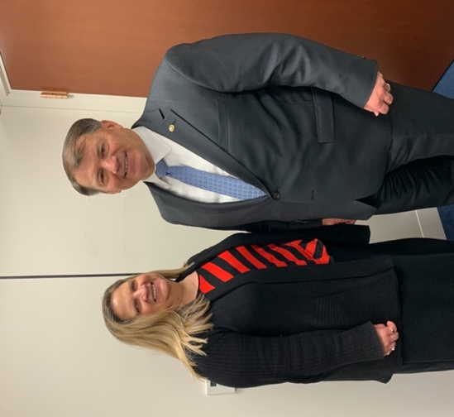
Monday was Legislative Seminar day. We started the day with Mark Schultz, Acting Administrator, Rehabilitation Services Administration. He shared what is happening with WIOA (Workforce Innovation and Opportunity Act). Diane Burstein, Director, of the FCC shared what has happened and what is happening with CVAA. She shared what networks have audio description. How to access it on your tv and accessible boxes available through your cable company at no extra cost. Accessible Air Travel and Flying Dogs was the next topic. Livaughn Chapman from Department of Transportation shared what’s happening with transportation. Maggie Hart, counsel, shared how ACB worked to create legislation in West Virginia to allow blind and visually impaired residents to independently and privately vote absentee. Our luncheon speaker was Charles Cooper, Managing Director, Signal Group. He shared political insider insights of the 2020 election. Our first speaker after lunch was Barbara Raimondo, Executive Director, Conference of Educational Administrators of Schools and Programs for the Deaf. She shared how the Cogswell-Macy Act will ensure blind and visually impaired students will receive fair and appropriate education. Clark Rachfal, Director of Advocacy and Governmental Affairs talked about our first imperative to be discussed tomorrow on Capitol Hill. Medicare Demonstration of Coverage for Low Vision Devices Act. It talks about the profound impact it will have on Medicare recipients who need access to low vision devices. Staying on the medical topic. We all know how a lot of medical equipment is inaccessible for the blind and visually impaired. ACB shared how they are promoting the development of and requirement for accessible durable medical equipment. By early afternoon we were hearing about another topic that affects all of us, transportation. Pat Sheehan, ACB board, was the moderator for a panel discussion on Accessible Transportation, now and in the future. We learned about the work going on in the transportation realm, from those who travel by foot to driving in an autonomous vehicle. Our panelists were: Claire Stanley, Advocacy and Outreach Specialist, Heidi Simon, Deputy Director, America Walks, Malcom Glenn, Head of Global Policy for Accessibility and Underserved Communities, Uber, Eric Danko, Director, Federal Affairs, Cruise Automation. Clark Rachfal and Claire Stanley talked about the other two imperatives to be discussed on Capitol Hill. The first one is the FAST Act. The second is autonomous vehicles. They both deal with transportation concerns. After all the wonderful presenters we had the opportunity to hear from our sponsors. They were: Cisco Systems, JP Morgan Chase, Charter, Vispero, Aira, Cruise Automation, En-Vision America, Sprint, and Uber. We ended the day with Tell Claire Everything! She wanted to hear about issues, concerns we are encountering and if we had any solutions. ACB feels this is important for us to share with them so they are able to help advocate to make improvements and changes.
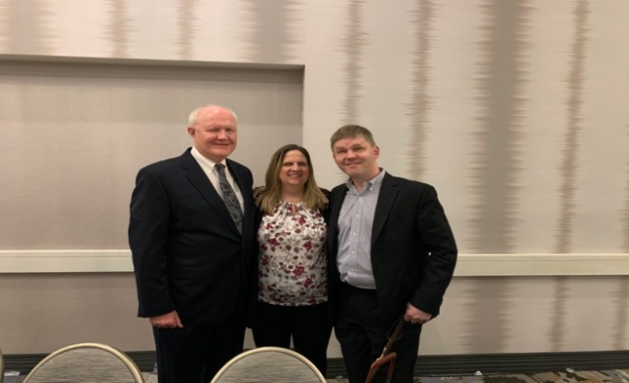
Tuesday was Capitol Hill Day. We all had to reach out to our own legislatures ahead of time to set up appointments to meet with them or their staff. I had ours setup by mid-January with all three offices interested in visiting with us. Since Seth wasn’t able to come, I was all by myself! Our headquarters to start and end was at the Rayburn cafeteria. We were all on our own. They had a few volunteers if people needed assistance. I was able to take Uber with a couple people from California. They were seasoned attendees. When we got to the Rayburn building, I found the cafeteria. My first appointment was with Senator Thune. His office is in the Dirkson building which is about a 10 to15 minute walk from where I was at. Claire said, I know you can do this. She recommended I take Uber over there since it was raining. I got an Uber and off I went. When I got to the Dirkson building the line was extremely long! When I got through security, they didn’t have any volunteers either. I found my way to Senator Thune’s office. I met with Senator Thune and his legislative assistant who were really interested in what I had to say. He asked if there were issues back in South Dakota he needed to be aware of. I shared with him some concerns. He agreed there is cause for concern and they will be looking into things. I was then escorted over to the Hart building where Senator Rounds was located. I met with his State Deputy Chief of Staff and a legislative aide. They were also interested in the imperatives. At first, I was told Senator Rounds wanted to visit with me but wasn’t available due to a vote in the Senate. Not long after the Senator came in! He stated he wanted to visit with me, and he would get to the Senate later. Next it was over to Longhorn where Congressman Johnson is located. I was informed when I made the appointment that Congressman Johnson would not be available, so I met with his legislative assistant. It also was a good meeting. We were instructed to fill out a survey concerning our experiences for the day. I was asked by Dan, Clark, and Claire to visit with Senator Thune about co-sponsoring a bipartisan bill concerning Medicare. I did speak with him about it and said he would look into it. Both Senators agreed I gave some very good examples and reasons.
A few things that stood out. Senator Thune asked to have a picture with me before I could ask for one. ACB commented how well Senator Thune’s office works with them. When Senator Rounds found out I had to switch airlines due weather in Chicago he went above and beyond for me. He had someone from his staff pick me up at the hotel and they stayed with me until my assistance arrived. They provided me with cell numbers for his staff if I encountered problems on the way and wanted to know when I was home safely. Senator Thune said he was so impressed with me for traveling by myself, having to change airlines, and coming to Capitol Hill alone. I really appreciated the extra efforts provided by each legislative office to ensure my safety. Saturday night I met with our ACB board liaison, Mike Talley. He introduced me to more leaders in ACB. There is so much more I could share. My busy schedule did not allow time for any fun sightseeing. Maybe next time. It was a wonderful experience and I hope to attend again.
Top picture is Senator Thune and Koni Sims. Second picture is Senator Rounds and Koni Sims. Third picture is Dan Spoone, ACB President, Koni Sims, and Eric Bridges, Executive Director of ACB.
Koni Sims
This was featured in the April 2020 newsletter.
Learning in the Apple Tree
Young children love to play and learn in the trees and tree houses. What a time to learn with your friends at a unique spot. On March 6, 2020 young preschool children had that opportunity at Appletree Daycare in Sioux Falls, South Dakota. Appletree was gracious enough to offer an invitation to SDAB to stop over at their 41st street location to educate the children on blindness and different skills one who is blind may use on a daily basis. Two groups of preschool age children were split into groups of about 5 to 7 children and transferred through different stations learning all about blindness. Stations were hands on and open to questions.
Deb Versteeg was kind enough to offer some time to show the youngsters all about the Perkins Brailler. At this location children were given his or her name in braille, a sample card with braille on it, and a chance to observe Deb doing some braille. At a different station Nick Pavel read a story book in braille to them. He also had a velcro braille cell and asked the children to identify what letter he made. “It’s a great opportunity to educate kids at a young age about blindness” states Nick. When that station time was up, children moved to a station concerning guide dogs presented by Virginia Miller and Wiggles. Wiggles stole the show here! Virginia spoke of proper handling of a dog and taught the children different rules of a guide dog. After the children visited all three locations came a treat and juice to the hungry mouths.
An enormous thank you to Randy and the entire Appletree Daycare staff for their hospitality and help making this day an enjoyable day for all! I know for myself watching the children faces light up with enthusiasm and joy, taking it all in, and realizing the hurdles and triumphs of blindness on a daily basis made this day a huge success. Koni had some material made up for children that were unable to attend and some material for the youngsters to bring home and share with his or her family. We plan on going to the other three Apple Tree locations. We are waiting for it to be safe to have close contact with the children. Again, we appreciate all the work from Koni Sims, Randy Stewart, and Apple Tree Daycare. Below are pictures of children enjoying the event.
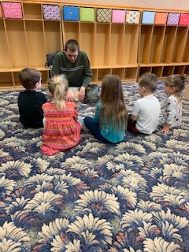
Eric Rippentrop
This was originally seen
in the July 2020 issue.

I Need Help!!
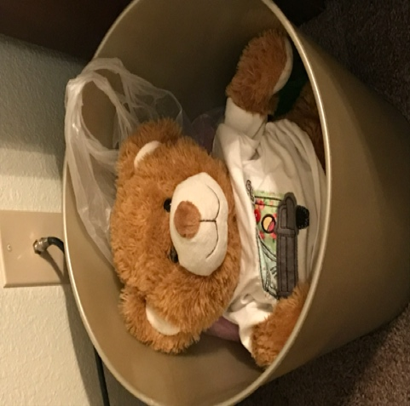
A few years ago, I got a brand-new owner. My first thought was everything is going to be great with my new owner and I was excited! Boy, was I wrong! I was not at Nick's apartment for 24 hours, and he put a Vikings shirt on me. He enjoyed it, but I thought it was torture! Not to mention that it’s a little loud at Nick's place during football season, especially when the Vikings are playing. I have also gotten to hear some catch phrases that I've never heard before, such as “big bucks”, “no whammies”, “will the mystery challenger enter and sign in please”, and “survey says?”. When the opportunity came to go on vacation, I was thrilled! The big reason is because I really haven't gone anywhere. I did make it to Ski for Light the past few years. One year, I actually made an appearance, and another year, he just kept me sitting underneath the nightstand and I had no choice but to listen to all the crazy conversations that took place until 3 or 4 a.m. As a matter of fact, that was the year he forgot me in Deadwood, and I had to be shipped back to him in a box. Sadly, I was stuck in that awful box until July. Apparently, my owner decided it’s time to move to a new apartment, so he decided to move me to the box to the garbage can. I have been in the new apartment, and I am still sitting in that garbage can. He won't let me out! It may be the safest place especially with COVID, but I want to get out of the can and move to the couch! Am I asking too much? I think not! Needless to say, I am counting down the days until I get a new owner because I have a sneaky feeling that I'm not going to be going anywhere anytime soon. Even if I do go on a vacation with Nick, he will probably forget me again. I'm probably going to need counseling when I get a new owner. This is a little traumatizing. But until then, I guess I am stuck with Nick for now.
Nick Pavel
The Traveling Bear
In 2005 the South Dakota Association of the Blind (SDAB) began a project to assist our organization in raising some money and educating people about blindness. It all started when two of our association members attended the American Council of the Blind (ACB) Conference & Convention in Las Vegas. They brought back a stuffed bear to auction off at our annual state Convention.
We had a lot of fun bidding on the stuffed bear at our auction. Then we got the idea that SDAB Bear could be our mascot. Whoever had the highest bid for the bear would take him home for the year. During that time SDAB Bear would travel with its temporary auction winning friend to add a little spark to presentations we did for children and adults. The following year SDAB Bear would be brought back for our meeting to be auctioned again. The winning friend would write a letter to describe where SDAB Bear had been during the past year. Everyone found this to be a lot of fun, and now, it is generally the culmination for the year’s convention activities.
SDAB Bear has traveled several places and taken part in educating groups about braille, mobility (white canes & guide dogs) adaptive aids, assistive technology and social help in meeting people who are blind and visually impaired.
SDAB Bear’s letters confirm that he has spent time in elementary schools, Day Care Centers & nursing homes. He has spent time in Hawaii, the Black Hills, Aberdeen (School for the Blind & Visually Impaired), and he has even traveled to the American Printing House for the Blind with one of our members who served on its Board of Directors.

SDAB Bear’s most recent trip was a Ski for Light Activity in Deadwood, South Dakota. Of course, with this much handling, it must be admitted that SDAB Bear is not the same bear originally brought back in 2005. New bears have been adopted to replace the original one. The question remains as to the gender of the bear. Three years ago, a good friend of SDAB dressed the SDAB Bear up in a beautiful ballerina outfit. She traveled like a queen for a while. More recently, SDAB Bear has been sporting a Vikings tee shirt. I guess he enjoys sports too.
At each annual meeting of the SDAB, there is always talk about who will bid the highest to take the bear home. This is an enjoyable activity, and SDAB Bear continues to be part of our Association for help, fun and laughter.
Chelle Hart 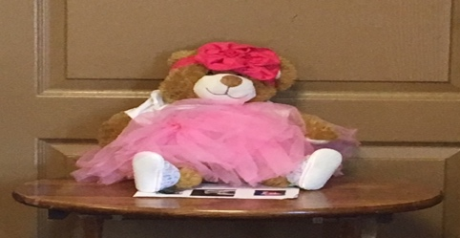 Pictured is our bear as a ballerina!
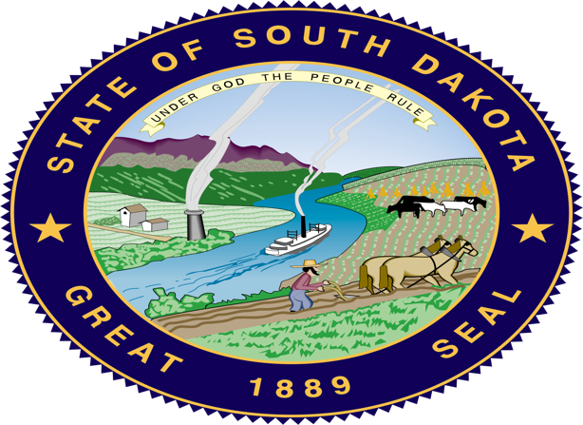
History of the South Dakota Great Seal
This Photo by Unknown Author is licensed under CC BY-SA
The Great Seal of the State of South Dakota was designed while the area was a territory in 1885. The outer ring of the seal contains the text "State of South Dakota" on the top and "Great Seal" on the bottom. Also the year of statehood, 1889. Inside the inner circle of the seal contains the state motto "Under God the People Rule". The picture features hills, a river with a boat, a farmer, a mine, and cattle. The items in the image are to represent the state's commerce, agriculture, industry, and natural resources.
Use of the South Dakota state seal is governed under South Dakota state law as follows:
1-6-3.1. Use of seal or facsimile without authorization Prohibited-Violation as misdemeanor. No person may reproduce, duplicate, or otherwise use the official seal of the State of South Dakota, or its facsimile, adopted and described in 1-6-1 and 1-6-2 for any for-profit, commercial purpose without specific authorization from the secretary of state. A violation of this section is a Class 1 misdemeanor.
1-6-3.2. Sale of seal facsimile without authorization Prohibited-Violation as misdemeanor. No person may sell or offer for sale a replica or facsimile of the official seal of the State of South Dakota, adopted and described in 1-6-1 and 1-6-2, without the specific authorization from the secretary of state. A violation of this section is a Class 1 misdemeanor.
1-6-3.3. Royalty for use of seal-Educational purposes excepted. The secretary of state shall charge a royalty for the privilege of using the state seal. The secretary of state may not charge a royalty if the state seal is used for an educational purpose. All royalty fees collected pursuant to this chapter shall be deposited in the state general fund.
Many color representations of the South Dakota state seal on the Internet are not an accurate representations of the color seal for South Dakota, as the current representation of the state deal is designated in state law
1-6-1. State seal Adopted-Reproductions. There is hereby adopted as the official colored seal of the State of South Dakota, a reproduction of the seal, described in article XXI, section 1 of the Constitution of the State of South Dakota, and made in conformity therewith but whose proportions and colored detail are set out specifically in accord with an original painting of the great seal produced by John G. Moisan of Fort Pierre and shall be the basis for all reproductions of the great seal of the State of South Dakota. The South Dakota Secretary of State is the designated custodian of the South Dakota State Seal.

This information was taken from an internet article.

Blind Blunders
One day when I was making chili for supper, I grabbed a can of kidney beans. As I can’t read labels, I was going by the picture and it was dark and looked like beans. As I poured it into the kettle with the other ingredients, I realized I was putting beets into my chili instead of beans. We ate it anyway and it actually was okay!
When I was at lunch one day with my coworkers, I was setting my food and drink onto the table in front of me. My supervisor began to laugh and asked me why I had brought beer as a beverage. I blushed and put it back into my lunch box to a round of laughter from the rest of the people at the table.
Virginia Miller

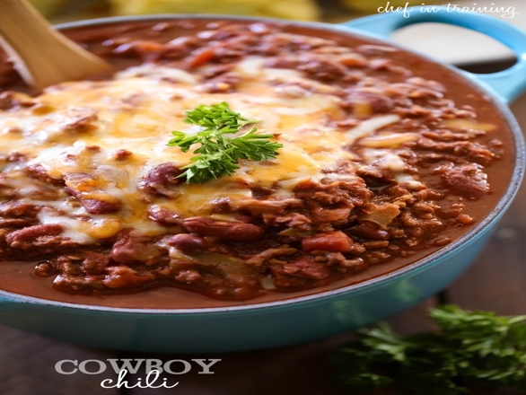
Pictured is a bowl of chili.

Courtesies to Extend to a Person with a Dog Guide
The driver of a vehicle shall yield the right of way to any blind pedestrian carrying any visible white cane or accompanied by a guide dog. This is part of the laws concerning white canes and guide dogs. This is an important law, as hybrid cars can’t be heard, and environmental noises can camouflage the sound of other vehicles.
It is important to leave a working dog or one at rest alone. Distractions can cause the guide or handler to lose focus and may put them in danger.
Always ask before approaching or bending to pet a dog guide. Many handlers do not want their guides disturbed or to allow then to get too social.
Service animals must be allowed in restaurants and businesses. The handler is expected to control their guide and ask to be seated where the guide can be out of other customers way. Dog guides are trained to walk on the left side of the sidewalk and street. This is for the safety of the handler and it is also a wise way for pedestrians to walk on streets and roads. Handlers cannot be expected to move out of the way of others, but they will walk around people and obstructions in their path. It is important to remember that the handler is blind and cannot see where to move to. When walking with a person with a visual impairment, it is important to let the handler deal with the dog and not to call the guide by name instead of pointing things out to the individual being guided. Some people who are visually impaired may prefer to have their guide follow instead of walking along side another person.
Point out things, such as, steps, change in direction, doorways, or other obstacles that may be coming up.
Pictured above is Virginia Miller walking her guide dog Wiggles. He is extra special since he shares his birthday with Louis Braille on January 4th. Wiggles is now five. He has been working with Virginia for over three years.

As Eye Cook It

Submitted by LaVonne Raap

Stovetop Stuffing Hotdish
2 pounds hamburger – uncooked
1 box of chicken Stovetop stuffing
1 can cream of mushroom soup
1 can cream of chicken soup
1 can cream of celery soup
1 soup can of milk
Spread hamburger in a 9x13 pan. Top with stuffing mix. Combine soups and milk, heat until smooth. Put on top of stuffing. Bake at 350 degrees for 1 hour.

Orange Jell-O Salad
1 carton cool whip
1 3oz box orange Jell-O
1 12 oz contain of cottage cheese
1 can mandarin oranges – drained
Mix cool whip and Jell-O. Add cottage cheese and oranges. Mix together.

Grape Salad
Red grapes
¼ cup sour cream
½ cup brown sugar
Combine sour cream and brown sugar. Add red grapes. Mix together til grapes are covered. Number of grapes depends how covered you want them.

Looking Ahead to 2021 SDAB Convention
Hope this finds you doing well. All I can say about this time is that it is a new year and a new hope for the future. I also hope that some of you have been able to benefit from the Covid vaccine.
I had a nice visit with Alex, the assistant manager of the Fairfield Inn about the 2021 convention. Here are the things that we talked about.
We set the dates for Friday and Saturday, September 17 and 18 2021. We will be at the Fairfield Inn and Suites in Aberdeen.
We will be using the breakfast room for the majority of the meetings and the board room for smaller group meetings, such as, SDAB board.
We cannot take over the breakfast area until 10:00 AM each day, but that will leave the meeting room open for smaller group discussions.
I have reserved a block of 20 rooms with a charge of $115 per room, per night. State rates will apply, but those rooms will be separate from the block of rooms. There are 10 rooms with king size beds and 10 with 2 queens. So hopefully, people can share.
We will be allowed to bring in our own food for meals other than breakfast, which is complimentary. They also said that there will be coffee and cookies throughout the day available.
If you have questions, please contact Virginia Miller at 605-261-8921 or email ginnyandterry@siouxvalley.net. Hope to see everyone there! Stay tune for updates through the year.
Virginia Miller
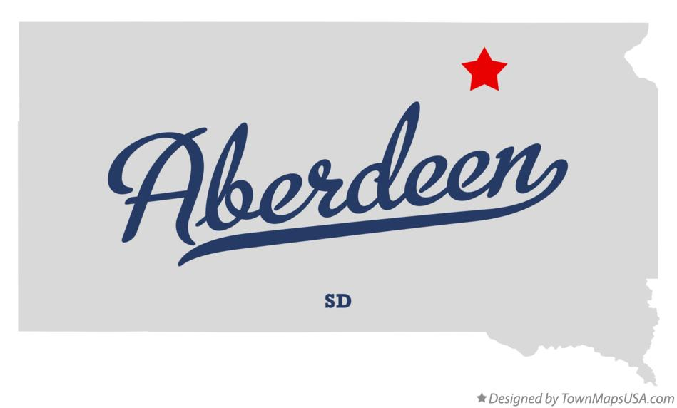
Pictured is a state outline of South Dakota with a red star for Aberdeen.

U.S. Department of Transportation Announces Final Rule

on Traveling by Air with Service Animals
Washington – The U.S. Department of Transportation today announced that it is revising its Air Carrier Access Act (ACAA) regulation on the transportation of service animals by air to ensure a safe and accessible air transportation system. The final rule on Traveling by Air with Service Animals can be found here.
The Department received more than 15,000 comments on the notice of proposed rulemaking. The final rule announced today addresses concerns raised by individuals with disabilities, airlines, flight attendants, airports, other aviation transportation stakeholders, and other members of the public, regarding service animals on aircraft.
The final rule:
- Defines a service animal as a dog that is individually trained to do work or perform tasks for the benefit of a person with a disability.
- No longer considers an emotional support animal to be a service animal.
- Requires airlines to treat psychiatric service animals the same as other service animals.
- Allows airlines to require forms developed by DOT attesting to a service animal’s health, behavior and training, and if taking a long flight attesting that the service animal can either not relieve itself, or can relieve itself in a sanitary manner.
- Allows airlines to require individuals traveling with a service animal to provide the DOT service animal form(s) up to 48 hours in advance of the date of travel if the passenger’s reservation was made prior to that time.
- Prohibits airlines from requiring passengers with a disability who are traveling with a service animal to physically check-in at the airport instead of using the online check-in process.
- Allows airlines to require a person with a disability seeking to travel with a service animal to provide the DOT service animal form(s) at the passenger’s departure gate on the date of travel.
- Allows airlines to limit the number of service animals traveling with a single passenger with a disability to two service animals.
- Allows airlines to require a service animal to fit within its handler’s foot space on the aircraft.
- Allows airlines to require that service animals be harnessed, leashed, or tethered at all times in the airport and on the aircraft.
- Continues to allow airlines to refuse transportation to service animals that exhibit aggressive behavior and that pose a direct threat to the health or safety of others; and
- Continues to prohibit airlines from refusing to transport a service animal solely based on breed.
The final rule will be effective 30 days after date of publication in the Federal Register.

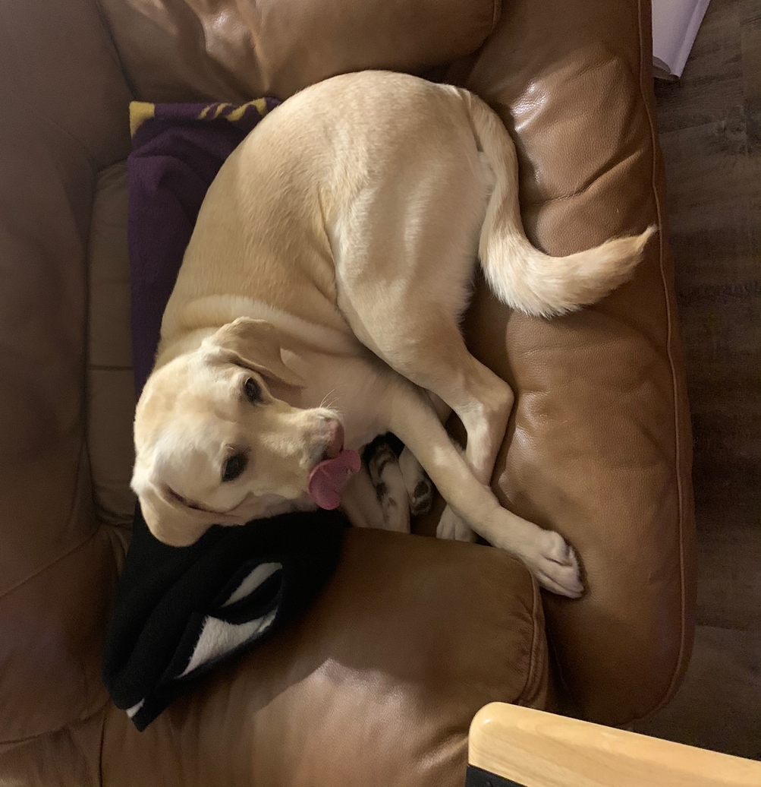
Pictured is a yellow lab “Wiggles”, owned by Virginia Miller.

SDAB 2021 Membership Form
One name per form
Name: ____________________________________________________
Address: ____________________________________________________
City/State/Zip: ____________________________________________________
Phone: Home:____________________ Cell: ________________
Email: _______________________________________________
___Fully Sighted ___Blind/Visually Impaired
Are you a student? ____Yes ___No
If yes, Name of School: ______________________
Are you a Veteran? ____Yes ___No

Membership dues are $20.00 per person. Dues are for the 2021 membership year. Please pay dues by March 1, 2021. Please make checks payable to SDAB.

Your membership entitles you to receive a copy of our newsletter. If you are interested in receiving any or all of the following formats, please indicate:
___Large print ___Braille ___E-mail ___None
SDAB is an affiliate of the American Council of the Blind (ACB). Your membership entitles you to receive their publication, the “Braille Forum.” Please indicate the format you wish to receive:
___Large print ___Braille ___E-mail __Digital Cartridge ___None

Information continued on next page

Please remember to submit both pages when sending your application.

2021 Membership Form Continued
SDAB is your membership organization. We would love to hear from you. Please share some special dates with us.
Birthday - MM/DD/YYYY: _____________________________________
Anniversary – MM/DD/YYYY: __________________________________
Any other special dates or events: _____________________________
SDAB is always looking for members to participate on committees. We all have talents and abilities. Please mark which committee(s) you would like to serve on.
Finance: ____ Program/Social: ____ Membership: ____
Amendments/Bylaws/Constitution: ____ Resolution/Legislation: _____
Nominating: ___ Awards/Stipends: ____ Publicity: ____

What projects would you like to see SDAB work on? ____________________________________________________________
____________________________________________________________
____________________________________________________________

Please be advised SDAB does not disclose your personal information without your permission.
Mail to:
SDAB Membership
PO Box 1622
Sioux Falls, SD 57101

SDAB First Class Mail
P.O. Box 1622 Free Matter for the Blind
Sioux Falls, SD Postal Manual Section 135
57101-1622 U.S. Code 39, Sec 3403-5

TO:

If you have any suggestions or articles for the next newsletter have them submitted by March 1st. Please contact Koni at: koni.l.sims@gmail.com or the SDAB mailbox.

